CSNB4313- Assignment 1
Software Testing: Critical Case Study
INDIVIDUAL ASSIGNMENT (5%)

DONE BY
ALHATHAL NAIF MASHAAN D
SW01084553

Software Testing in Critical Systems: Banking System Analysis
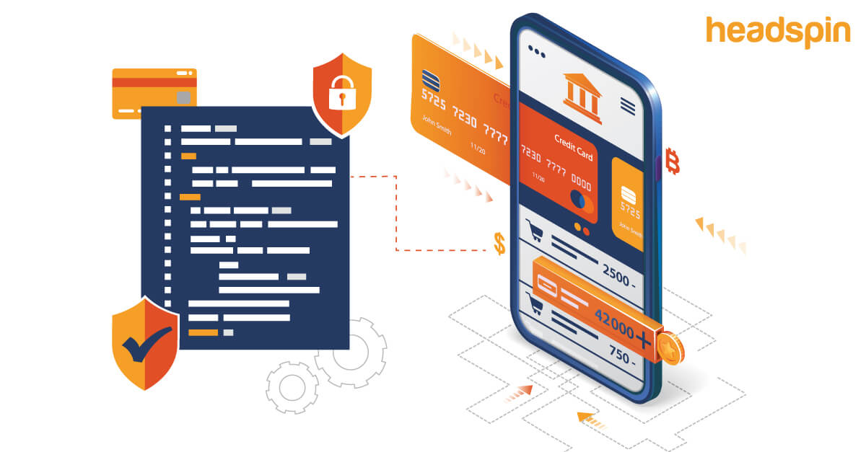

Part 1: System Description
A banking system is a software-based platform used by financial institutions to manage financial transactions, customer accounts, and digital payments. These systems are critical because they process millions of transactions daily and store sensitive financial data.
According to recent studies, banking systems are highly complex and prone to failures due to software bugs, cyberattacks, and system overloads. In fact, major banks experienced 158 IT failures in just two years, resulting in over 803 hours (33 days) of outages that affected millions of users.
This shows how essential reliability and proper testing are in such systems.

Part 2: Scenario of Failure
If software testing is not properly conducted, serious issues can arise:
- Incorrect fund transfers
- Duplicate or missing transactions
- Unauthorized withdrawals
- System crashes during peak usage
Real-world examples highlight these risks. In 2025, banking system glitches caused customers to experience failed payments, frozen accounts, and an inability to access money during critical times, such as salary days.
Additionally, technical failures have resulted in incorrect deposits and unauthorized withdrawals, showing how software bugs directly impact users.

Part 3: Impact Analysis

1. Impact on Users
- A survey found that 1 in 3 banking customers experienced technical failures in a single year, affecting their ability to access money or make payments.
- This leads to stress, inconvenience, and loss of trust.

2. Impact on Organization
- Banks suffer reputational damage and customer loss. Research shows that 30% of users are likely to switch banks after experiencing technical issues.
- This directly impacts long-term business growth.

3. Safety Impact
- Although not physical safety, financial instability can severely affect people’s daily lives, especially those dependent on timely payments (e.g., salaries, bills).

4. Financial Loss
- Software failures can cause massive economic damage. A global report found that software failures resulted in $1.7 trillion in financial losses and affected 3.6 billion people.
- Additionally, banks often pay compensation—for example, one outage alone cost millions in payouts to affected customers.

Part 4: Role of Testing
Proper software testing can significantly reduce these risks:

Testing Types
- Functional Testing: Ensures transactions work correctly
- Performance Testing: Prevents system crashes during heavy traffic
- Security Testing: Protects against cyberattacks and data breaches
- Regression Testing: Ensures updates don’t break existing features

Validation and Verification
- Verification: Ensures the system is built correctly according to requirements
- Validation: Ensures the system meets real user needs
Studies show that most failures are caused by software bugs and security vulnerabilities, which could be prevented through proper testing processes.

Part 5: Reflection
Software testing is essential because even small errors in critical systems like banking can lead to massive financial and reputational damage.
From this assignment, I learned that real-world systems frequently fail due to inadequate testing, and these failures affect millions of users globally. Proper testing ensures system reliability, security, and user trust, making it a crucial part of software development.

